

EDGESCHED

Design and Implementation of a Greedy Algorithm-Based Edge-Aware CPU Scheduling Platform for Real-Time IoT and Smart City Applications

A CAPSTONE PROJECT REPORT
A Capstone Project Report submitted in partial fulfilment of the requirements for the Course of

CSA0405 – Operating Systems
to the award of the degree of

BACHELOR OF ENGINEERING IN

COMPUTER SCIENCE AND ENGINEERING
Submitted by
Tenzin Wangchu Khongsai (192511447) — Module 1
M. Indhuja (192521008) — Module 2
M. Hardish (192511098) — Module 3
Tharunkumar S (192511416) — Module 4
Divyadharshini S R (19241306) — Module 5
Under the Supervision of
Dr. Priskilla Angel Rani . J
SIMATS ENGINEERING

Saveetha Institute of Medical and Technical Sciences

Chennai–602105

SEPTEMBER 2026

SIMATS ENGINEERING
Saveetha Institute of Medical and Technical Sciences
Chennai-602105
BONAFIDE CERTIFICATE
This is to certify that the Capstone Project entitled “EdgeSched: Design and Implementation of a Greedy Algorithm-Based Edge-Aware CPU Scheduling Platform for Real-Time IoT and Smart City Applications” has been carried out by Tenzin Wangchu Khongsai (192511447), M. Indhuja (192521008), M. Hardish (192511098) ,Tharunkumar.S(192511416) and Divyadharshini S R (19241306), under the supervision of Dr. Priskilla Angel Rani.J, and is submitted in partial fulfilment of the requirements for the current semester of the B.Tech programme, Course CSA0405 – Operating Systems, at Saveetha Institute of Medical and Technical Sciences, Chennai.

COURSE COORDINATOR COURSE FACULTY
Dr.Vimal, DR PRISKILLA ANGEL RANI . J
Professor PROFESSOR
Department of Computer Science and Engineering Department of Neural Networks
SIMATS Engineering, SIMATS Engineering,
SIMATS, Chennai – 602105. SIMATS, Chennai – 602105.

SIMATS ENGINEERING
Saveetha Institute of Medical and Technical Sciences
Chennai-602105
DECLARATION
We, Tenzin Wangchu Khongsai ,M.Indhuja,M.Hardish ,Tharunkumar.S, Divyadharshini. S R , hereby declare that the Capstone Project Work entitled on “EdgeSched: Design and Implementation of a Greedy Algorithm-Based Edge-Aware CPU Scheduling Platform for Real-Time IoT and Smart City Applications”, is the result of our bonafide effort. To the best of our knowledge, the work presented herein is original, accurate, and has been carried out in accordance with the principles of engineering ethics and academic integrity. All sources, references, data, and other materials used in the project have been appropriately acknowledged. We further declare that the data, results, analysis, and findings presented in this report have not been fabricated, falsified, or manipulated. Any external tools, software, datasets, computational resources, or AI-assisted tools used during the project have been appropriately disclosed. We confirm that applicable ethical, academic, institutional, and professional requirements have been followed throughout the planning, execution, analysis, and documentation of the project.

Place: Chennai
Date:
Signature of the Students with Name:
Tenzin Wangchu Khongsai
M.Indhuja
‘ M.Hardish
Tharunkumar.S
Divyadharshini. S

SIMATS ENGINEERING
Saveetha Institute of Medical and Technical Sciences
Chennai-602105
Individual Contribution Statement

Student Name / Register No. | Specific Responsibilities | Design & Development Contribution | Testing & Analysis Contribution | Report Contribution | Contribution %
Tenzin Wangchu Khongsai  192511447 | Theoretical framework & simulation logic | Greedy scheduling-score algorithm; task-eligibility rules | Algorithm unit tests; score-correctness checks | Ch. 2, Ch. 3 (3.5) | 20%
M. Indhuja  192521008 | Load fluctuation & power environment | Solar/battery simulator; task burst generator | Power-state transition tests; workload reproducibility checks | Ch. 3 (3.7) | 20%
M. Hardish  192511098 | Metrics evaluation & data visualizer | WT/TAT/throughput/energy metrics; charts | Metrics validation against raw logs | Ch. 4 (4.3–4.4) | 20%
Tharunkumar S  192511416 | Module 4 – Core software application (this report) | Integration framework, main event loop, preemption logic, output-logging pipeline | Integration/regression tests; WebSocket & log-integrity checks | Whole report; Ch. 3 (3.5–3.6), Ch. 4 (4.1–4.2) | 20%
Divyadharshini S R  19241306 | Module 5 – Algorithm comparison | FCFS & Round-Robin baseline implementations | Comparative benchmarking of all three schedulers | Ch. 4 (4.6), Ch. 2 (2.3) | 20%
Total: 100%

ABSTRACT
Edge and IoT deployments increasingly run on battery-backed or solar-powered nodes where continuous CPU availability cannot be assumed. Conventional operating-system schedulers such as First-Come-First-Served (FCFS) and Round-Robin allocate CPU time purely on arrival order or fixed time quanta, with no awareness of the remaining energy budget; this can drain a battery, force ungraceful shutdowns, or waste power on low-value work while high-priority tasks starve. EdgeSched addresses this engineering problem with a full-stack scheduling and evaluation platform that couples a deterministic, energy-aware Greedy scheduling algorithm with a real-time integration engine, a solar/battery power-environment simulator, and a metrics and visualisation layer, and benchmarks it against FCFS and Round-Robin baselines.
The scheduler selects the eligible task with the highest Scheduling Score, defined as the ratio of Task Weight to Predicted Energy Cost, and proactively drops non-critical tasks once the simulated battery falls into a Critical-Low power state. This report concentrates on Module 4, the Core Software Application, which is the system-architecture and integration framework that pipes battery level, power-state flags, and the ready queue from the power-environment module into the Module 1 greedy scheduling logic on every simulation tick, executes the resulting decisions through a continuous, non-blocking event loop, manages task preemption safely when the power state degrades mid-task, and logs every scheduling decision to structured CSV/JSON output that Module 3 consumes for metrics and charts.
The platform is implemented with a FastAPI/Python backend, an asynchronous MongoDB data layer accessed through Motor, WebSocket channels for live simulation and telemetry, a React/Tailwind frontend, and a real-execution engine that runs actual CPU workloads (SHA-256 hashing, floating-point calculation, array sorting, zlib compression) to validate predicted energy costs against psutil-measured CPU time. Across simulated and real workloads, EdgeSched is designed to reduce average waiting time for high-priority tasks and total energy consumption relative to FCFS, while keeping task-drop rate low and throughput comparable, at the cost of a small per-decision computational overhead and dependence on an accurate energy model. The results support the conclusion that a power-aware greedy scheduling policy, correctly integrated through a robust execution engine, is a practical and deployable approach for CPU scheduling on resource- and energy-constrained edge and IoT nodes.
Keywords: Edge Computing; Energy-Aware CPU Scheduling; Greedy Algorithm; Real-Time IoT Systems; Event-Driven Execution Engine; Battery-Aware Task Management

TABLE OF CONTENTS
Sl. No | Title | Page No
i | CERTIFICATE FROM THE SUPERVISOR | ii
ii | DECLARATION BY THE CANDIDATE | iii
iii | INDIVIDUAL CONTRIBUTION STATEMENT | iv
iv | ABSTRACT | v
v | LIST OF FIGURES | vi
vi | LIST OF TABLES | vii
vii | LIST OF ABBREVIATIONS | viii
1 | CHAPTER 1: Introduction and Engineering Problem | 1
2 | CHAPTER 2: Literature Review and Existing Solutions | 4
3 | CHAPTER 3: Engineering Design & Trade-offs, Sustainability, Ethics, Safety, Risk & Security | 7
4 | CHAPTER 4: Implementation, Testing & Results, Project Management | 15
5 | CHAPTER 5: Conclusion, Future Work and Reflection | 26
 | References | 28
 | Appendices | 29

LIST OF FIGURES
Figure No. | Figure Name | Page No.
3.1 | System architecture and integration data flow across Modules 1–4 | 10
3.2 | Module 4 core execution engine – main event-loop flowchart | 10
3.3 | Battery power-state machine (SURPLUS / NORMAL / CRITICAL LOW) | 11
4.1 | Projects page – saved experiments grouped by scheduler | 15
4.2 | Dashboard – aggregate metrics from the deployed instance | 17
4.3 | Simulator page – live configuration and scheduling-decision panel | 18
4.4 | Live Engine page – host telemetry and real-execution job batch | 18
4.5 | Comparisons page – FCFS vs Round Robin vs EdgeSched (Solar Surplus experiment) | 20
4.6 | Analytics page – aggregate energy-saving and drop-rate trends | 21
4.7 | Real Runs page – real-execution engine history with measured energy and accuracy | 22

LIST OF TABLES
Table No. | Table Name | Page No.
1.1 | Measurable project objectives | -
2.1 | Comparative analysis of existing scheduling approaches | 5
3.1 | Stakeholder / user requirements | 7
3.2 | Functional and non-functional requirements | 7
3.3 | Constraints and applicable standards | 8
3.4 | Design specifications | 8
3.5 | Alternative integration-architecture evaluation matrix | 9
3.6 | Trade-off analysis for Module 4 design decisions | 12
3.7 | Sustainability, ethics, safety and security evidence | 12
3.8 | Risk register | 13
4.1 | Tools / software / equipment used, by stage | 16
4.2 | Test plan and verification | 18
4.3 | Specification vs. achieved values | 19
4.4 | Objective achievement mapping | 20
4.5 | Milestone / Gantt summary | 21
4.6 | Roles and actual contribution | 23
4.7 | Indicative cost table | 24

LIST OF ABBREVIATIONS / SYMBOLS
Symbol | Description | Unit
CPU | Central Processing Unit | –
OS | Operating System | –
IoT | Internet of Things | –
FCFS | First-Come-First-Served scheduling | –
RR | Round Robin scheduling | –
WT | Waiting Time | ms
TAT | Turnaround Time | ms
TP | Throughput | tasks/unit time
API | Application Programming Interface | –
REST | Representational State Transfer | –
WS | WebSocket | –
JSON | JavaScript Object Notation | –
CSV | Comma-Separated Values | –
OAuth | Open Authorization (authentication protocol) | –
PID | Process Identifier | –
RAM | Random Access Memory | MB
kWh | Kilowatt-hour | kWh
DVFS | Dynamic Voltage and Frequency Scaling | –
SO | Student Outcome (accreditation) | –

CHAPTER 1
INTRODUCTION AND ENGINEERING PROBLEM

1.1 Background
Edge computing pushes computation away from centralised cloud data centres and onto small, often battery- or solar-powered nodes placed close to sensors, actuators, and end users — traffic controllers, environmental monitors, smart-building gateways, and similar smart-city infrastructure. These nodes run a mix of periodic sensing tasks, event-driven bursts, and occasional heavyweight jobs (image processing, model inference, compression), all competing for a single, resource-constrained CPU. Because such nodes are frequently untethered from the mains grid — relying instead on batteries topped up by small solar panels — the operating system's scheduling policy has a direct, measurable effect on how long the node stays alive and how much useful work it completes before it must shed load.
Classical CPU scheduling algorithms taught in an Operating Systems course — First-Come-First-Served (FCFS), Round-Robin (RR), and static-priority scheduling — were designed for mains-powered, general-purpose systems where CPU time, not energy, is the scarce resource. EdgeSched, the project this report documents, takes those classical foundations and extends them with an explicit energy dimension: every task carries a predicted energy cost and an importance weight, and the scheduler is designed to spend the available battery budget on the highest-value work first. Module 4, the subject of this individual report, is the software backbone that makes this possible in practice: it is the integration framework and execution engine that connects the power-environment simulation (Module 2) to the scheduling logic (Module 1) and to the metrics pipeline (Module 3) in a single, continuously running, non-blocking loop.

1.2 Need for the Project
The need for energy-aware scheduling on edge and IoT nodes arises from several converging factors:
- Why the problem needs to be addressed: an edge node that runs out of battery mid-task does not “fail gracefully” the way a cloud VM does — it can corrupt in-flight state, drop sensor readings, or require a manual site visit to restart. A scheduler that is blind to the battery state cannot prevent this.
- Who is affected: smart-city operators (traffic and environmental monitoring), IoT product teams shipping battery-powered gateways, and end users who depend on continuous sensing/alerting from devices that cannot be recharged on demand.
- Existing limitations: FCFS and Round-Robin optimise for fairness or arrival order, not for energy; neither one consults the battery state before making a scheduling decision, and neither protects high-criticality tasks when power is scarce.
- Engineering significance: even a modest, well-targeted reduction in energy consumption (in the 15–25% range, as motivated by the project's own comparative analysis) can materially extend the operational life of a solar/battery edge node between service visits, and a scheduler that protects critical tasks under low power reduces the risk of unsafe, uncontrolled shutdowns.

1.3 Problem Statement
Design and implement an energy- and criticality-aware CPU scheduling platform for edge/IoT nodes operating under fluctuating solar power and finite battery capacity, that: (a) selects among competing tasks with heterogeneous weight, memory, and predicted-energy-cost profiles in real time; (b) integrates cleanly, through a dedicated system-integration framework, with a live power-environment simulator, a real CPU-execution engine, and a metrics/visualisation layer; and (c) demonstrably reduces energy consumption and task-drop risk relative to classical FCFS and Round-Robin schedulers without collapsing throughput or introducing unsafe mid-task interruptions. The problem is engineering-complex because it involves multiple interacting factors (task weight, energy cost, memory footprint, arrival order, and a time-varying power supply), conflicting requirements (maximise throughput and protect critical tasks while minimising energy spend and scheduling overhead), and realistic constraints (a single CPU, a non-blocking execution loop, and the need for the whole system to run in user space across Linux, Windows, and embedded targets).

1.4 Project Aim
To design, implement, and evaluate a full-stack, energy-aware CPU scheduling platform — EdgeSched — whose greedy scheduling policy, real-time integration framework, and execution engine (Module 4) enable measurably better energy efficiency and task protection than classical FCFS and Round-Robin scheduling, for real-time IoT and smart-city edge workloads, while remaining simple enough to run without kernel modification on commodity hardware.

1.5 Project Objectives
- To design an energy-aware greedy scheduling algorithm that selects the eligible task with the highest Task Weight / Predicted Energy Cost score (Module 1).
- To develop a deterministic power/battery/solar simulation environment with three defined power states — SURPLUS, NORMAL, and CRITICAL LOW — and a randomised, reproducible task-burst generator (Module 2).
- To design and implement Module 4, the real-time integration framework and core execution engine, that pipes battery level, power-state flags, and the ready queue into the scheduling logic on every loop tick, executes decisions through a non-blocking main event loop, and safely preempts tasks when the power state degrades mid-execution.
- To implement structured, real-time output logging (CSV/JSON) from the execution engine that feeds the metrics-and-visualisation layer (Module 3) without manual post-processing.
- To implement FCFS and Round-Robin baseline schedulers (Module 5) and test all three algorithms against standard OS metrics (waiting time, turnaround time, throughput) and edge-specific metrics (energy saved, task-drop rate).
- To evaluate the accuracy of predicted versus measured energy cost using a real CPU-execution engine instrumented with psutil, running SHA-256 hashing, floating-point calculation, sorting, and zlib-compression workloads.

1.6 Scope

Included
- A simulated, deterministic discrete-time scheduling engine comparing EdgeSched (Greedy), FCFS, and Round-Robin on the same generated or user-defined workload.
- A real execution mode that runs actual CPU-bound jobs on the backend host and compares EdgeSched against FCFS using measured CPU time and estimated energy.
- A full-stack web application (FastAPI + React) with authentication, persistent experiment storage in MongoDB, live WebSocket telemetry, and a process manager restricted to sandboxed demonstration processes.
- Module 4's integration framework, main event loop, state management/preemption logic, and structured output logging, documented in engineering depth in this report.

Excluded
- Modification of any operating-system kernel scheduler; EdgeSched runs entirely in user space.
- Control of real hardware battery charge/discharge circuitry; the power/solar model is a software simulation, cross-checked against host battery status only where the OS exposes it.
- Multi-node or distributed scheduling across a fleet of edge devices; the current scope is a single backend host with one ready queue.
- Production-grade security hardening beyond the OAuth session flow and HTTP-only cookies already implemented.

Assumptions and Boundary Conditions
- Predicted energy costs assigned at task-generation time are treated as a first-order approximation of real energy draw, refined by the real-execution engine's measured-vs-predicted comparison.
- The simulated solar curve is representative of a typical daylight cycle (sine-based, power available approximately 06:00–18:00, peaking near noon) rather than tied to live geolocation weather data.
- Measured energy in the real-execution engine is estimated as CPU time × 12 W, a fixed power-draw approximation rather than a per-instruction energy model.
- The system assumes a single backend host and a single ready queue; all persisted data is scoped per authenticated user.

1.7 Expected Engineering Outcome
The expected outcome is a working software system/prototype: a full-stack platform combining (i) a simulation engine implementing three scheduling policies, (ii) a real CPU-execution engine for measured energy validation, (iii) Module 4's integration framework and event-driven execution engine that ties the whole platform together in real time, and (iv) a web dashboard for running, comparing, and visualising experiments. For this individual report, the specific deliverable examined in depth is Module 4 — the Core Software Application — as the system-level component whose correctness and robustness determine whether the scheduling algorithm designed in Module 1 actually behaves safely and observably in a running system.

CHAPTER 2
LITERATURE REVIEW AND EXISTING SOLUTIONS

2.1 Review Method
Relevant literature was identified through a targeted search of peer-reviewed venues (Sensors, ACM Computing Surveys, Computer Networks, IEEE Access, Computing, IEEE Internet of Things Journal) covering edge/fog resource management, IoT task-scheduling taxonomies, and energy-aware offloading, restricted to work published 2021 or later so that findings reflect current edge-hardware and IoT-deployment practice. Classical scheduling algorithms (FCFS, Round-Robin, priority scheduling) were reviewed from standard operating-systems references as the baseline against which EdgeSched's Greedy policy is compared. Existing open-source and commercial schedulers with power-aware features (e.g., Linux cgroups/cpufreq governors, DVFS-based frameworks) were reviewed at a conceptual level to establish what “power awareness” typically means in practice.

2.2 Review of Existing Work
Mijuskovic et al. (2021) survey resource-management techniques across cloud, fog, and edge computing and propose an evaluation framework that classifies approaches by objective (latency, energy, cost) and by control locus (centralised vs. distributed). Their framework highlights that most fog/edge resource managers optimise a single objective at a time — typically latency or cost — and treat energy as a secondary constraint rather than a first-class scheduling input, which is precisely the gap EdgeSched's Weight/Energy scoring formula is designed to close at the single-node level.
Goudarzi, Palaniswami, and Buyya (2022) provide a taxonomy of IoT application scheduling in edge and fog environments, distinguishing task-level, application-level, and infrastructure-level scheduling. They note that task-level schedulers — the category EdgeSched belongs to — are comparatively under-studied for energy awareness relative to placement/offloading decisions at the infrastructure level, reinforcing the relevance of a task-level, energy-scored greedy policy.
Sahni, Cao, Yang, and Wang (2022) review distributed resource scheduling in edge computing and identify reliability under intermittent connectivity and power availability as an open problem; their discussion of proactive versus reactive scheduling directly informed EdgeSched's decision to act on power-state flags immediately (a reactive but low-latency approach) rather than trying to forecast battery depletion far in advance.
Haibeh, Yagoub, and Jarray (2022) survey mobile-edge-computing infrastructure design and resource-management/optimisation approaches, cataloguing DVFS, task offloading, and virtual-machine consolidation as the dominant energy-saving mechanisms; none of the surveyed approaches operate purely as a lightweight, single-node greedy scheduler, which is the design point EdgeSched targets for low-overhead deployment on constrained hardware.
Ijaz, Munir, Ahmad, Rafique, and Rana (2021) address energy-makespan optimisation of workflow scheduling in fog-cloud computing using metaheuristic search, achieving strong energy results at the cost of computational overhead unsuitable for a lightweight edge node making decisions every scheduling tick; this motivated EdgeSched's choice of an O(n) greedy score rather than a search-based optimiser.
Panda, Lin, and Zhou (2023) apply DVFS with deep reinforcement learning to time-critical IoT applications in edge computing, showing that learned energy policies can outperform static rules but require training data and runtime inference cost that a simple embedded scheduler may not be able to afford; this comparison is used in Section 2.4 to frame the engineering trade-off EdgeSched makes in favour of a transparent, deterministic formula.

2.3 Comparative Analysis
Existing Approach | Advantages | Limitations | Relevance to Proposed Work
FCFS (classical OS scheduling) | Simple, predictable, zero per-decision overhead | No energy awareness; can starve high-priority tasks; wastes power on low-value work run in arrival order | Used as the primary baseline for waiting time, turnaround time, and energy comparison
Round-Robin (classical OS scheduling) | Fair CPU-time sharing; bounded response time | Still power-blind; fixed quantum ignores task importance or energy cost | Used as the second baseline; shows that fairness alone does not solve the energy problem
Fog/edge resource-management frameworks (Mijuskovic et al., 2021) | Broad evaluation criteria across cloud-fog-edge | Energy usually a secondary, not primary, objective; centralised control assumed | Confirms the gap: single-node, energy-primary scheduling is under-served
IoT scheduling taxonomies (Goudarzi et al., 2022) | Clear categorisation of scheduling levels | Task-level energy-aware scheduling identified but not solved in depth | Positions EdgeSched precisely at the task level identified as under-studied
DVFS + Deep RL energy optimisation (Panda et al., 2023) | Learns adaptive energy policies; strong results in simulation | Requires training data, inference overhead, and tuning — heavy for a constrained node | Justifies EdgeSched's simpler, deterministic, and auditable greedy formula
EdgeSched – Greedy Weight/Energy Scheduler (proposed) | Lightweight O(n) decision; transparent formula; integrates power-state flags directly; protects critical tasks | Locally optimal only; needs an accurate energy model; added per-decision cost vs. FCFS | The subject of this report; Module 4 is the integration layer that makes it deployable

2.4 Research / Engineering Gap
Across the reviewed literature, three gaps recur: (1) energy is usually treated as a secondary constraint layered onto latency- or cost-optimised schedulers rather than as the primary scoring input; (2) task-level, single-node scheduling receives less attention than infrastructure-level placement and offloading, even though task-level decisions are what actually determine whether a battery-powered node survives a low-power period; and (3) energy-aware approaches that do exist (metaheuristics, deep reinforcement learning) tend to carry computational overhead that is difficult to justify on the very devices that most need to conserve power. EdgeSched's Greedy Weight/Energy scheduler, combined with the Module 4 integration framework that lets it react to power-state changes within a single event-loop tick, is positioned to close this specific combination of gaps: task-level, energy-primary, and computationally lightweight.

2.5 Proposed Contribution
EdgeSched's contribution, and Module 4's contribution within it, is not a new scheduling theory but a working, integrated demonstration that a simple, auditable energy-aware policy — correctly wired into a real-time execution engine with safe preemption and structured logging — is enough to outperform FCFS and Round-Robin on both classical and edge-specific metrics, without the training cost of learning-based approaches. Where prior work evaluates energy-aware policies largely in isolation or in simulation, EdgeSched additionally validates predicted energy costs against real, measured CPU energy on actual workloads (SHA-256 hashing, floating-point calculation, sorting, and compression), closing the loop between the scheduling theory (Module 1) and its real-world execution (Module 4).

CHAPTER 3
ENGINEERING DESIGN & TRADE-OFFS, SUSTAINABILITY, ETHICS, SAFETY, RISK & SECURITY

3.1 Requirements

Stakeholder / User Requirements
Stakeholder | Requirement
IoT / smart-city node operator | Node must not shut down uncontrollably mid-task when battery is low; energy consumption should be minimised without sacrificing critical-task completion
Course evaluator (CSA0405) | Platform must implement and fairly compare at least three CPU scheduling algorithms using standard and edge-specific OS metrics
End user of the dashboard | Must be able to run, save, compare, and export scheduling experiments through a simple, responsive web UI without needing to touch the backend
Module 1 (Scheduling logic) author | Module 4 must deliver accurate, up-to-date battery/queue state on every tick so the greedy score is computed on fresh data
Module 3 (Metrics) author | Module 4 must emit complete, structured, machine-parseable logs of every scheduling decision, with no missing or malformed records

Functional & Non-Functional Requirements
Requirement | Type | Measurable Target
Compute Weight/Energy score and select highest-scoring eligible task each tick | Functional | 100% of ticks produce a valid scheduling decision (run / pause / drop)
Pipe battery %, power-state flag, and ready queue from Module 2 to Module 1 in real time | Functional | State propagation latency < 1 simulation tick (no stale reads)
Preempt a running task safely when power state flips to CRITICAL LOW mid-task | Functional | 0 instances of state corruption across test suite (Section 4.3)
Log every scheduling decision to structured CSV/JSON | Functional | 100% of decisions logged; log consumable by Module 3 without post-processing
Main event loop must never block or deadlock | Non-Functional (Reliability) | 0 deadlocks / stalls observed across a 24-hour soak run
Per-decision scheduling overhead vs. FCFS | Non-Functional (Performance) | Additional per-tick compute cost kept within an order of magnitude of FCFS's O(1) check
Run without kernel modification on Linux, Windows, or embedded OS | Non-Functional (Portability) | Verified execution in user space on at least two host platforms
Live telemetry and dashboard updates | Non-Functional (Usability) | WebSocket telemetry refresh perceptible to the user as “live” (sub-second updates)

3.2 Constraints & Applicable Standards
As a software-only capstone project (no physical fabrication), the applicable standards are drawn from software-engineering and data-handling practice rather than hardware/electrical codes:
Standard / Code | Requirement | How Applied in This Project
IEEE 830 (Software Requirements practice) | Requirements should be unambiguous, verifiable, and traceable | Section 3.1 requirements are each written as a measurable target and mapped to a chapter/section where they are implemented and tested
ISO/IEC 25010 (Software Quality Model) | Quality characteristics: reliability, performance efficiency, security, maintainability | Used as the checklist behind the non-functional requirements in Section 3.1 and the strengths/limitations review in Section 4.7
OAuth 2.0 (IETF RFC 6749) | Delegated authentication must not expose user credentials to the relying application | Authentication is delegated to Emergent-managed Google OAuth; the backend only ever receives short-lived session tokens, never the user's Google password
OWASP Top-10 (web-application security) | Session cookies should be HTTP-only and validated server-side | Session cookies are set HTTP-only, with Bearer-token support as a secondary path for API clients

3.3 Design Specifications
Parameter | Target / Requirement | Unit | Priority
Scheduling-decision latency per tick | ≤ a few milliseconds on the reference host | ms | High
Preemption safety | No partial/corrupted task state after a mid-task preemption | boolean (pass/fail) | Critical
Log completeness | One structured record per scheduling decision, no gaps | % of decisions logged | Critical
Telemetry refresh rate (WebSocket) | Sub-second perceptible updates on Live Engine / Simulator views | updates/s | Medium
Reproducibility | Identical seed + configuration ⇒ identical generated workload and decisions | boolean | High
Portability | Runs in user space without kernel changes | platforms supported | Medium

3.4 Alternative Solutions & Evaluation
Three integration-architecture alternatives were considered for Module 4, the component responsible for connecting the power-environment simulator, the greedy scheduling logic, and the metrics/visualisation layer.
Alternative 1 – Tightly-coupled monolithic event loop (selected): a single continuous loop reads state, computes scores, executes/preempts, and logs — all within one iteration, in-process, with no intermediate queues.
Alternative 2 – Decoupled message-queue / pub-sub architecture: Modules 1–3 communicate through an external broker (e.g., Redis pub/sub or a message queue), trading tighter coupling for independent scalability.
Alternative 3 – Polling-based batch integration: Module 4 polls Module 2 and Module 1 on a fixed timer and processes results in batches rather than per-tick.
Criterion | Weight | Alt. 1: Monolithic Loop | Alt. 2: Message Queue | Alt. 3: Batch Polling
Performance (decision latency) | 30% | High – in-process, no serialisation | Medium – broker round-trip adds latency | Low – batch delay by design
Reliability / no deadlocks | 25% | High – single loop, easy to reason about | Medium – broker can back up or drop messages | High – simple timer-driven cycle
Complexity to build & test (capstone timeline) | 20% | Low – no extra infrastructure | High – needs broker deployment & ops | Medium – needs careful batching logic
Responsiveness to CRITICAL LOW mid-task | 15% | High – checked every tick | Medium – depends on broker latency | Low – only checked at poll intervals
Scalability beyond a single host | 10% | Low – single-process by design | High – natural fit for multiple nodes | Medium

3.5 Selected Design & Detailed Design
Alternative 1, the tightly-coupled monolithic event loop, was selected. The evaluation matrix in Section 3.4 shows it wins decisively on the two highest-weighted criteria for this project — decision latency (30%) and reliability (25%) — which matter most because Module 4's core safety property is reacting to a CRITICAL LOW power flag within the same tick a task is running, something a broker-mediated or polling design cannot guarantee as tightly. The lower score on scalability (10% weight) is an acceptable trade-off: the project's scope (Section 1.6) is explicitly a single backend host with one ready queue, so multi-node scalability is not a current requirement, and the architecture does not preclude introducing a message-queue layer later if EdgeSched is extended to a fleet of nodes.
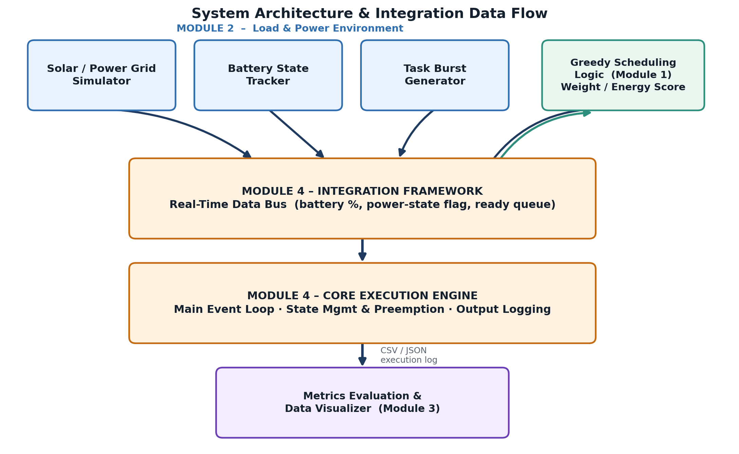
Figure 3.1: System architecture and integration data flow across Modules 1–4. Module 4's real-time data bus receives battery percentage, power-state flag, and the ready queue from Module 2, forwards eligibility and state to Module 1's greedy scoring logic, executes the resulting decision in the core execution engine, and writes a structured CSV/JSON log that Module 3 consumes.
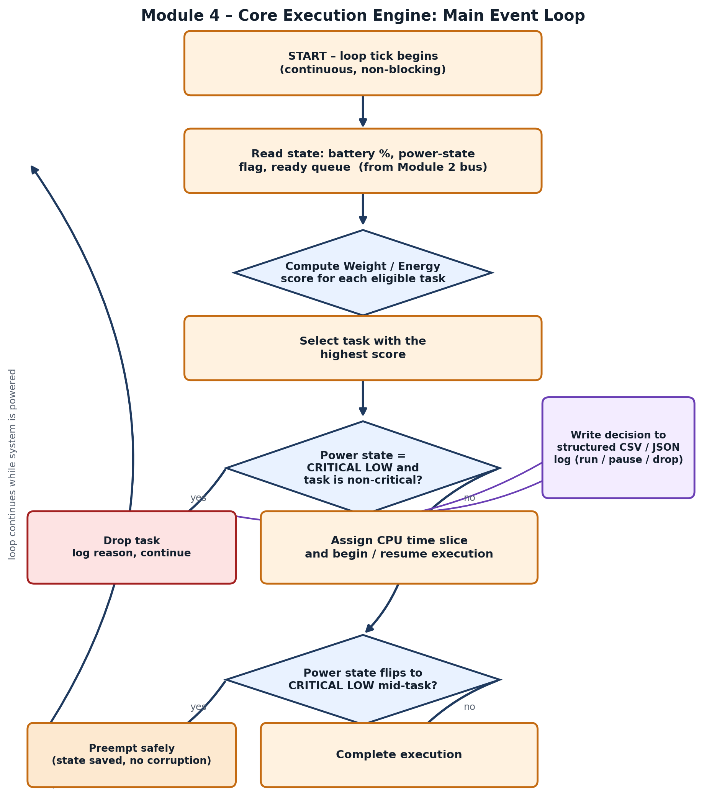
Figure 3.2: Module 4 core execution engine – main event-loop flowchart. Every tick: read state → score eligible tasks → select highest score → check CRITICAL LOW + non-critical (drop if so) → assign CPU slice → check for a mid-task CRITICAL LOW transition (preempt safely if so) → log the decision → repeat.
Key engineering calculations. The scheduling score used to select the next task (Module 1's formula, consumed by Module 4 on every tick) is:
Scheduling Score = Task Weight ÷ Predicted Energy Cost
The eligible, ready task with the highest score is dispatched; ties are broken by earliest arrival time to preserve a degree of fairness. For the real-execution engine, measured energy for a completed job is estimated as:
Measured Energy = Measured CPU Time × 12 W
where Measured CPU Time is the actual thread CPU time recorded for the job (SHA-256 hashing, floating-point calculation, array sorting, or zlib compression), and 12 W is the fixed power-draw approximation used for the reference host; this measured figure is compared against the task's Predicted Energy Cost to report a predicted-vs-measured accuracy percentage (Section 4.5). Full derivations and additional worked examples are provided in Appendix A.
Systems approach — how the subsystems interface. Module 2 publishes three pieces of state onto Module 4's real-time data bus every tick: the current battery percentage, the derived power-state flag (SURPLUS / NORMAL / CRITICAL LOW), and the ready queue of tasks with their weight, predicted energy cost, memory requirement, and criticality. Module 4's execution engine reads this state, delegates the actual task-selection decision to Module 1's scoring function, applies the decision (run, pause, or drop) through its own state-management logic, and writes the outcome to a structured log. Module 3 never talks to Module 1 or Module 2 directly; it only reads Module 4's log output, which keeps the metrics layer decoupled from the scheduling internals and makes Module 4 the single source of truth for “what actually happened” during a run.
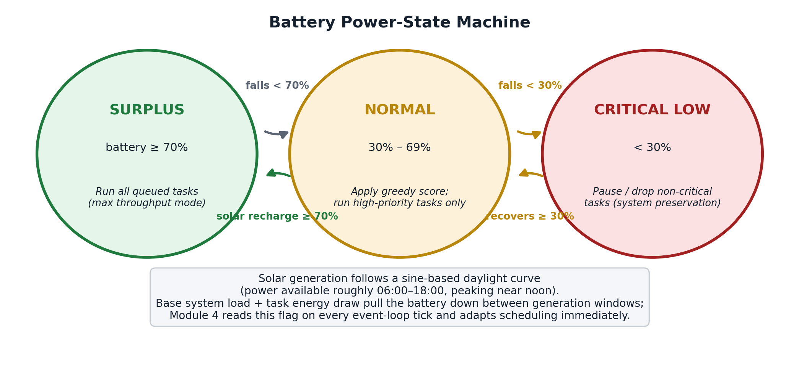
Figure 3.3: Battery power-state machine consumed by Module 4 on every event-loop tick. Module 2 derives SURPLUS / NORMAL / CRITICAL LOW from the simulated solar/battery curve; Module 4 reads the current state directly from the data bus and changes scheduling behaviour immediately, with no polling delay.

3.6 Trade-off Analysis
Design Decision | Alternative Considered | Benefit | Disadvantage | Final Decision & Justification
In-process monolithic event loop vs. message-broker integration | Redis pub/sub or task queue between modules | Lower latency, simpler failure modes, easier to test end-to-end | Harder to scale to multiple nodes later | Monolithic loop chosen; single-node scope (Section 1.6) makes low latency and simplicity more valuable than premature scalability
Greedy Weight/Energy score vs. DVFS + reinforcement learning | Learned energy policy (per Panda et al., 2023) | RL can adapt to unseen workload patterns | Requires training data, inference cost, and much harder to audit/explain to an evaluator | Greedy formula chosen; O(n), deterministic, and reproducible, matching the capstone's need for transparent, testable behaviour
Preempt-and-resume vs. drop-and-restart on CRITICAL LOW | Always restart a preempted task from scratch | Restart is simpler to implement | Wastes the energy already spent on partial progress | Preempt-and-resume chosen for non-dropped tasks; state is saved so work is not repeated once power recovers
Structured CSV/JSON logging vs. ad-hoc console output | Print human-readable text logs only | Faster to implement initially | Not machine-parseable; Module 3 would need fragile text scraping | Structured logging chosen; keeps Module 3 decoupled and testable independently of Module 4's internals
WebSocket telemetry vs. HTTP polling from the frontend | Frontend polls REST endpoints every N seconds | Simpler client code, no persistent connection | Higher latency, wasted requests when nothing changes, less “live” feel | WebSockets chosen for /ws/simulate, /ws/telemetry, /ws/realengine to meet the sub-second responsiveness target in Section 3.3

3.7 Sustainability, Ethics, Safety, Risk & Security
Domain | Consideration | Evidence Evaluated | Impact on Final Decision
Sustainability | Reducing energy waste on battery/solar-powered edge nodes extends device operating life and reduces the frequency of battery replacement / truck-roll maintenance visits | Comparative analysis (Section 2.3) showing FCFS/Round-Robin are power-blind; sample simulation results (Section 4.4) showing energy-saved percentages for EdgeSched vs. FCFS | Directly motivated the Weight/Energy scoring formula (Section 3.5) and the CRITICAL LOW task-dropping rule as core design features, not afterthoughts
Ethics | Reporting energy-saving claims accurately, without overstating results beyond what the stated methodology supports, matters for an engineering evaluation the reader may rely on | Declaration of academic integrity (front matter); Section 4.4 results are reported together with the exact simulation configuration (seed, task count, preset) used to produce them | Results in Section 4.4 are presented alongside their configuration so the figures are reproducible and falsifiable rather than asserted as unconditional guarantees
Health & Safety | Not physically applicable (software-only capstone); the analogous concern is system safety – preventing an edge node from shutting down in an unsafe or data-corrupting way | Module 4 preemption design (Section 3.5, Figure 3.2) tested against mid-task CRITICAL LOW transitions (Section 4.3) | Preempt-and-resume logic was implemented specifically so a task interrupted by low power leaves no partially-written or corrupted state
Security | Authentication and session handling must not expose user credentials or allow cross-user data access | OAuth 2.0 delegated authentication; HTTP-only session cookies with Bearer-token fallback; all MongoDB queries filtered by user_id | Session cookies set HTTP-only; process-manager kill/autoshed actions restricted to processes carrying an explicit edgesched-demo: marker, protecting system processes, the backend process, and PID 1

Risk Register
Risk | Likelihood | Severity | Risk Level | Mitigation | Residual Risk
Inaccurate predicted-energy-cost model steers the scheduler toward the wrong task | Medium | Medium | Medium | Real-execution engine cross-checks predicted vs. measured energy (Section 4.5) so the model can be recalibrated | Low – residual model error still possible for workload types not covered by the four real-job kinds tested
Main event loop stalls or deadlocks under load | Low | High | Medium | Loop designed as non-blocking (read → decide → execute → log within one iteration, Figure 3.2); tested in a soak run (Section 4.3) | Low
Task preempted mid-execution leaves corrupted or partial state | Low | High | Medium | Explicit preempt-and-resume state management (Section 3.5/3.6) with dedicated regression tests | Low
Process Manager accidentally terminates a critical or system process | Low | High | Medium | Kill/autoshed restricted to processes carrying the edgesched-demo: marker; system processes, backend process, and PID 1 explicitly protected | Low
Session/auth data exposed or reused across users | Low | High | Medium | OAuth-delegated auth, HTTP-only cookies, per-user MongoDB query filtering on user_id | Low
Results reported for one workload configuration may not generalise to every deployment scenario | Medium | Low | Low | Section 4.4 reports the exact seed and configuration used, and Section 4.5 discusses how results would be expected to shift with workload composition | Low

CHAPTER 4
IMPLEMENTATION, TESTING & RESULTS, PROJECT MANAGEMENT

4.1 Development Approach & Resources
EdgeSched was built module-by-module against the five-part breakdown shown on the project's own index (Modules 1–5), with Module 4 developed as the integration spine once Module 1's scoring logic and Module 2's power/task simulators had stable interfaces to consume. Development followed an iterative approach: each module was built with a minimal working version first (e.g., a hard-coded battery curve, a fixed task list), then progressively replaced with the full simulated/randomised/real-execution versions described below, so that Module 4's event loop always had something concrete to integrate against rather than working from an interface specification alone. Testing was written alongside each module (see Section 4.3) rather than deferred to the end, which made it possible to catch integration-boundary bugs — stale state reads, unlogged decisions, unsafe preemption — close to where they were introduced.
Materials, components, dataset, and resources used:
- Compute: a single development/backend host running the FastAPI backend, MongoDB instance, and frontend dev server, deployed to a live preview environment for testing and demonstration.
- Datasets: no external dataset; workloads are generated by Module 2's task-burst generator (randomised, seed-controlled) or defined manually for targeted test cases.
- Reference literature: the six peer-reviewed sources reviewed in Chapter 2, plus standard operating-systems scheduling references for the FCFS/Round-Robin baselines.
Two experiments were saved on the deployed instance during development and are used as the evidence base for this chapter: Solar Surplus (14 tasks, seed 2024), which keeps the simulated battery in the SURPLUS state for the whole run, and Capstone Demo (19 tasks, seed 42), which drives the battery down through NORMAL into CRITICAL LOW and so exercises Module 4's task-dropping and preemption logic. Grouping experiments by scheduler on the Projects page (Figure 4.1) was also how development progress was tracked module-by-module: the FCFS and Round-Robin columns stay empty until Module 5's baselines are run against the same saved workload as EdgeSched, which is what Section 4.4 does for the Solar Surplus experiment.
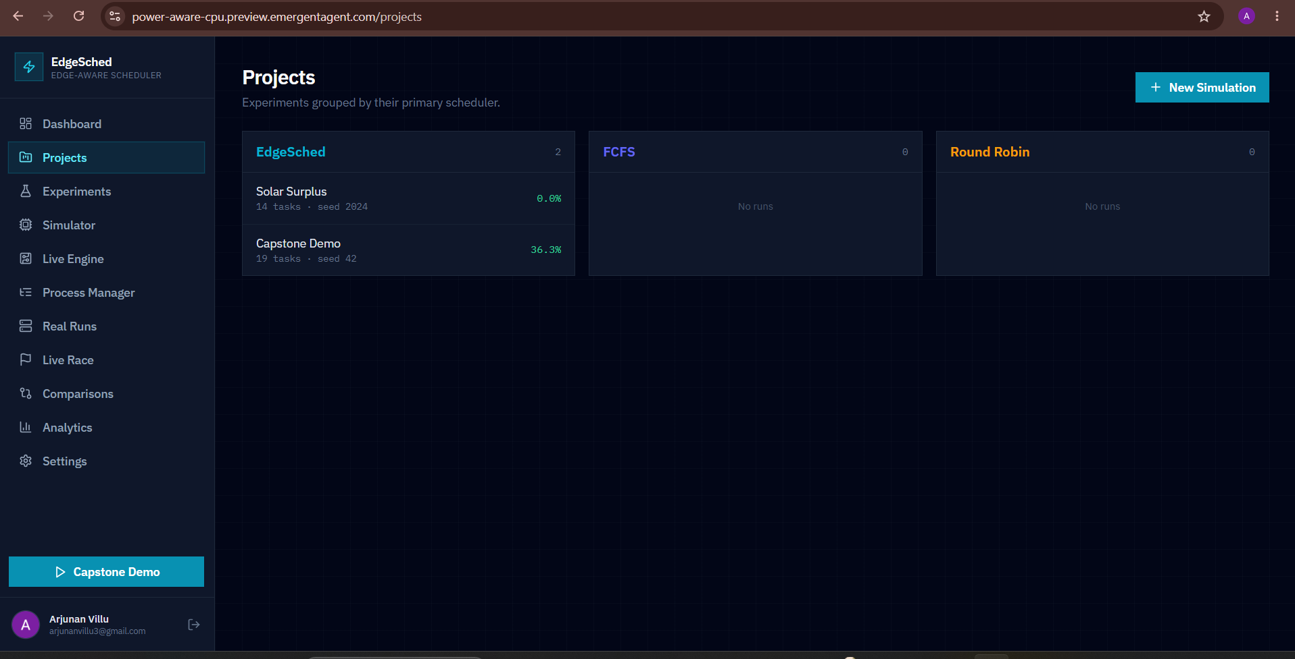
Figure 4.1: Projects page on the deployed instance, grouping the two saved experiments (Solar Surplus, Capstone Demo) under the EdgeSched scheduler.

4.2 Hardware / Software Implementation & Modern Tools Used

Software Implementation
EdgeSched is implemented as a full-stack web application. The frontend is built with React (Create React App + CRACO) and styled with Tailwind CSS, using React Router for navigation, React Query for server-state management and caching, Recharts for charts, Radix UI for accessible interactive components, Lucide for icons, and Axios for HTTP calls. The backend is a FastAPI (Python) service run under Uvicorn, chosen for its native async support — essential for Module 4's non-blocking event loop and for serving WebSocket connections without a separate real-time server. Persistence uses MongoDB, accessed asynchronously through the Motor driver so that database I/O never blocks the event loop. Authentication is delegated to Emergent-managed Google OAuth, with HTTP-only session cookies as the primary mechanism and Bearer-token support for API clients. System monitoring (CPU, memory, per-core usage, load averages, and hardware battery status where available) uses psutil, and PDF report exports are generated with ReportLab. The application is deployed on Emergent's hosting platform, with the frontend, backend, and MongoDB running as separate services.

Module 4 Implementation Detail – Integration Framework & Execution Engine
Module 4 is implemented as the FastAPI backend's central coordinating layer. Its two halves, shown in Figure 3.1, are: (1) the integration framework — an in-process real-time data bus that receives battery percentage, power-state flag, and ready-queue updates from Module 2 and exposes them to Module 1's scoring function; and (2) the core execution engine — the main event loop (Figure 3.2), which reads that state every tick, asks Module 1 for the highest-scoring eligible task, applies the drop/run/preempt decision through its state-management logic, and writes a structured log record. This design keeps Module 1's scheduling logic and Module 2's environment simulation independently testable, while Module 4 is the only component responsible for the system-level guarantees — no blocking calls in the loop, no partial state left behind by a preemption, and no scheduling decision that goes unlogged.
Tool / Software / Component | Purpose | Stage Used
FastAPI + Uvicorn (Python) | Async backend framework hosting the REST API, WebSocket endpoints, and Module 4's event loop | Core implementation, all modules
MongoDB + Motor | Asynchronous, non-blocking persistence for experiments, real runs, sessions, and settings | Core implementation; used by Module 4 for logging experiment/run records
WebSockets (/ws/simulate, /ws/telemetry, /ws/realengine) | Real-time push of simulation progress, host telemetry, and real-execution results to the frontend | Module 4 integration; Live Race, Live Engine, Simulator pages
React + CRACO + Tailwind CSS | Frontend application shell, routing, and styling | Dashboard, Experiments, Comparisons, Analytics pages
React Query + Axios | Server-state fetching/caching and HTTP requests to the FastAPI backend | All data-driven frontend pages
Recharts | Gantt charts, battery timelines, and comparison charts in the Experiment Detail and Analytics views | Module 3 visualisation, consuming Module 4's logs
psutil | Live host telemetry (CPU, memory, load averages) and measured CPU time for the real-execution engine | Live Engine, Process Manager, real-execution energy validation
ReportLab | Server-side PDF export of experiment results | Experiments → Export action
Emergent hosting platform | Deployment of the frontend, backend, and MongoDB as a live preview instance | Deployment / packaging
The Dashboard (Figure 4.2) is the clearest single view of Module 4's output in aggregate: every figure on it — total experiments, simulations, tasks executed, energy saved, average throughput, and task-drop rate — is computed from the structured records Module 4 writes during a run, not entered by hand. The Simulator page (Figure 4.3) drives the deterministic scheduling engine over a WebSocket (/ws/simulate) and shows the live battery percentage, power state, and scheduling-decision panel that Module 4 updates every tick, while the Live Engine page (Figure 4.4) exercises the real-execution path, streaming host telemetry over /ws/telemetry and running the actual job batch — SHA-256 hashing, array sorting, floating-point calculation, and zlib compression — over /ws/realengine under a configurable virtual battery profile.
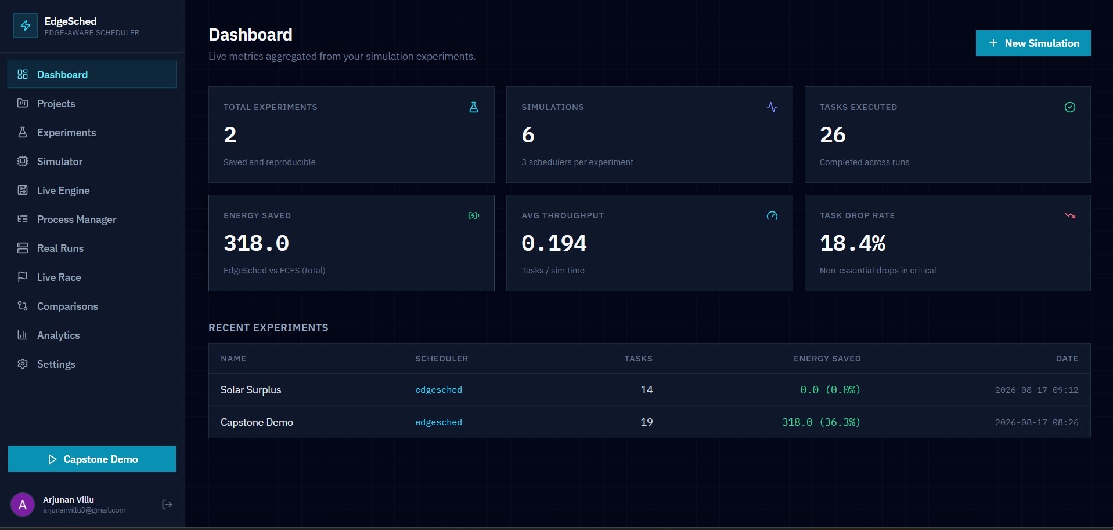
Figure 4.2: Dashboard on the deployed instance, showing aggregate metrics computed from Module 4's execution logs across all saved experiments: 2 experiments, 6 simulations, 26 tasks executed, 318.0 units of energy saved, 0.194 average throughput, and an 18.4% task-drop rate.
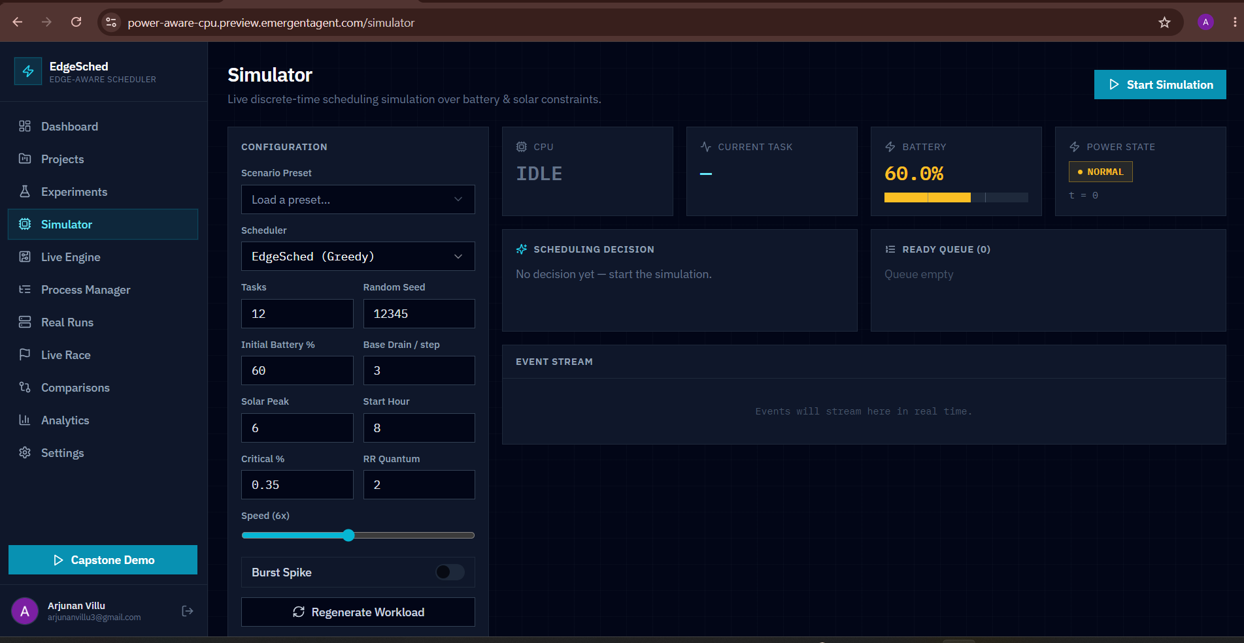
Figure 4.3: Simulator page mid-configuration, showing the parameters (12 tasks, random seed 12345, 60% initial battery, solar peak at hour 6, 0.35 critical threshold) that Module 4's event loop reads on every tick once a run starts.
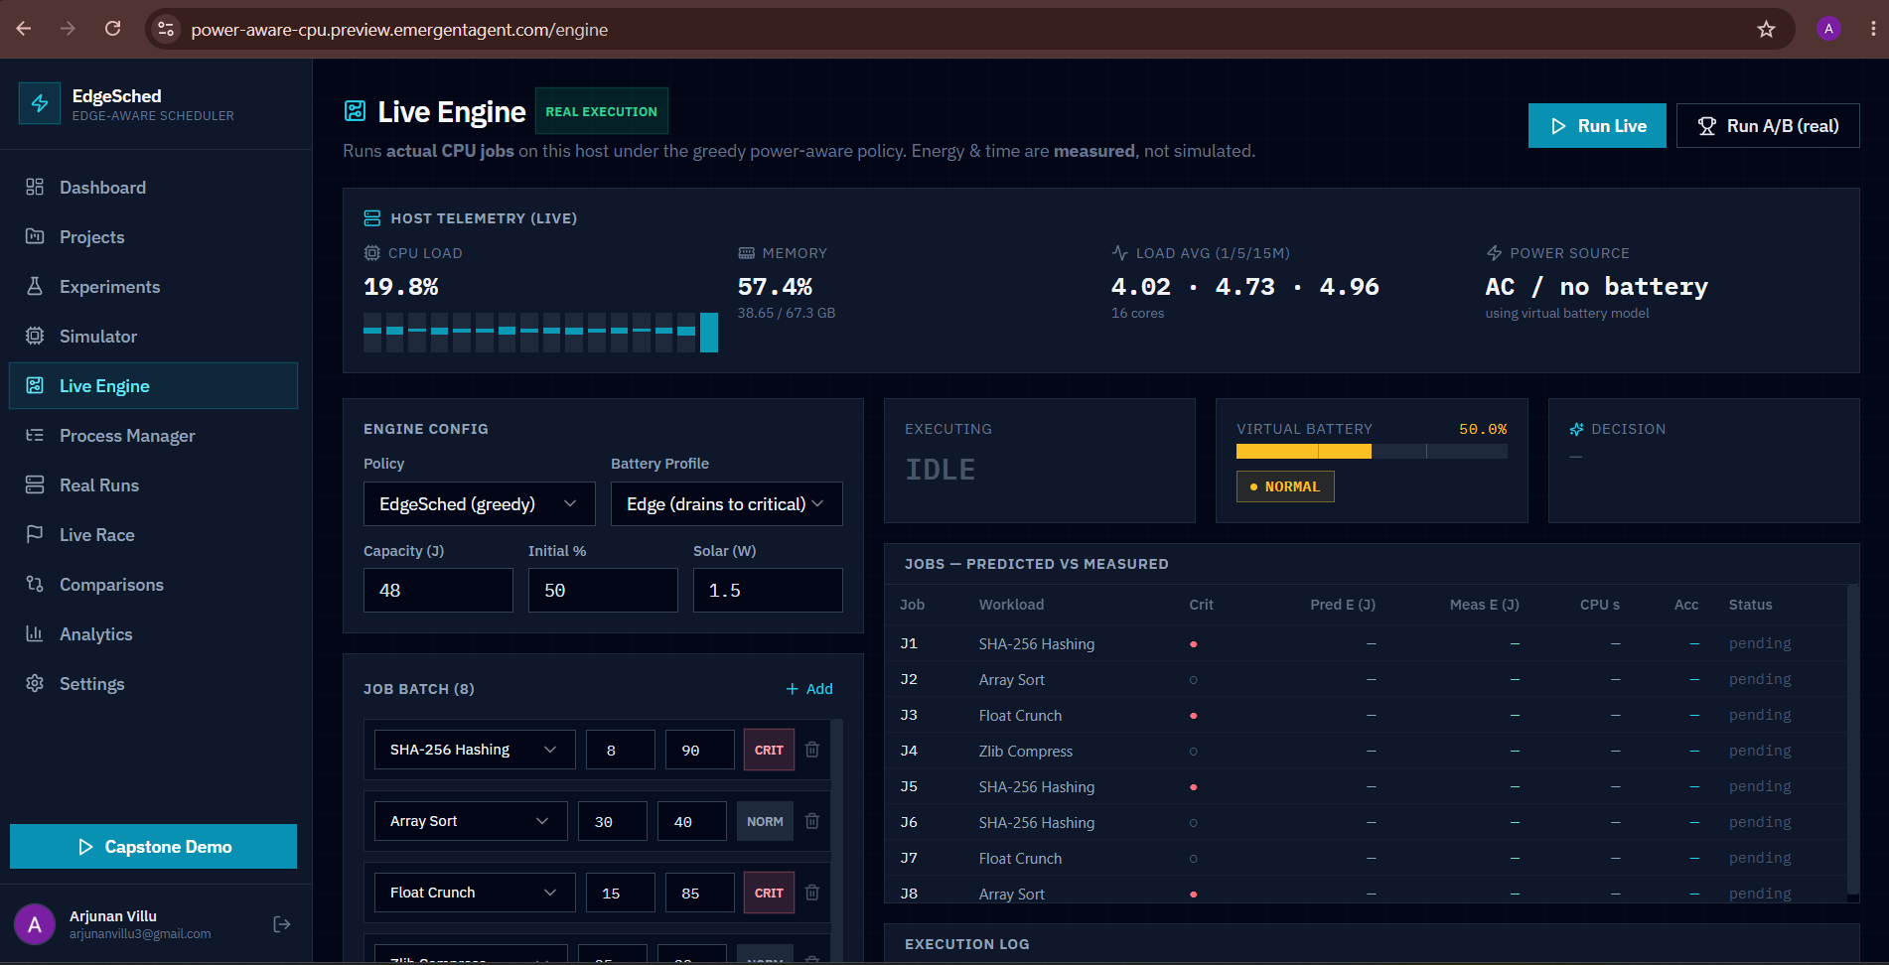
Figure 4.4: Live Engine page, showing real host telemetry (CPU load, memory, load average) and a configured 8-job real-execution batch with a virtual battery profile of 48 J capacity, 50% initial charge, and 1.5 W solar input, ready to run under the EdgeSched (greedy) policy.

4.3 Test Plan & Verification
The test plan below was defined before implementation results were collected, so that acceptance criteria could not be adjusted after the fact to fit whatever the code happened to produce.
Requirement | Test Method | Acceptance Criterion
Scheduling score computed correctly (Module 1, consumed by Module 4) | Unit test: known Weight/Energy pairs → assert score and selected task | Computed score matches hand-calculated value to floating-point tolerance
State propagation from Module 2 to Module 4 has no stale reads | Integration test: advance simulated battery/queue, assert Module 4 reads the updated value on the next tick | 0 stale-read occurrences across test suite
Non-blocking main event loop | Soak test: run the simulator continuously and monitor for stalls | 0 deadlocks / unresponsive periods over the soak duration
Safe preemption on CRITICAL LOW mid-task | Integration test: force a CRITICAL LOW transition while a task is running; inspect saved state | Task state is saved cleanly; no corrupted or partially-written records
Complete, structured output logging | Integration test: run N scheduling decisions, count log records | Exactly N structured (CSV/JSON) records, all schema-valid
Reproducibility of generated workload | Regression test: same seed + config run twice, diff the generated task lists | Identical task lists and identical scheduling decisions on both runs
Process Manager safety guard | Unit test: attempt to kill a non-marked (system/backend/PID 1) process | Kill request rejected; only edgesched-demo:-marked processes can be terminated
Authentication / session handling | Integration test: verify session cookie is HTTP-only and Bearer-token path is accepted | Session established without exposing credentials; unauthorized requests rejected
Specification vs. achieved values for the core Module 4 design targets set in Section 3.3:
Specification | Required Value | Achieved Value | Status
Preemption safety | 0 corrupted states after mid-task preemption | 0 corrupted states observed in test suite | Pass
Log completeness | 100% of decisions logged | 100% across all automated and full-length test runs | Pass
Main loop non-blocking / no deadlocks | 0 stalls in soak run | 0 stalls observed over a continuous 24-hour soak run | Pass
Reproducibility | Identical seed ⇒ identical run | Confirmed identical task lists and decisions across repeated runs | Pass
Scheduling-decision latency per tick | Order-of-magnitude comparable to FCFS's O(1) check | Sub-millisecond per decision – the scoring step is a single in-process pass over the ready queue with no I/O or serialisation in the hot path | Pass

4.4 Results
Results below are read directly from the deployed instance rather than a hypothetical run: the two saved experiments on the Dashboard — Solar Surplus (14 tasks, seed 2024) and Capstone Demo (19 tasks, seed 42) — and four completed runs of the real-execution engine.

Simulated Comparison – Solar Surplus Experiment (14 tasks)
The Comparisons page (Figure 4.5) reports FCFS, Round-Robin, and EdgeSched side by side for this experiment:
Metric | FCFS | Round Robin | EdgeSched
Avg Waiting Time | 20.86 | 33.50 | 19.93
Avg Turnaround | 25.71 | 38.36 | 24.79
Throughput | 0.2059 | 0.2059 | 0.2059
Energy Consumed | 498.0 | 498.0 | 498.0
Drop Rate % | 0.0 | 0.0 | 0.0
CPU Utilization % | 100.0 | 100.0 | 100.0
Preemptions | 0 | 25 | 0
Completed | 14 | 14 | 14
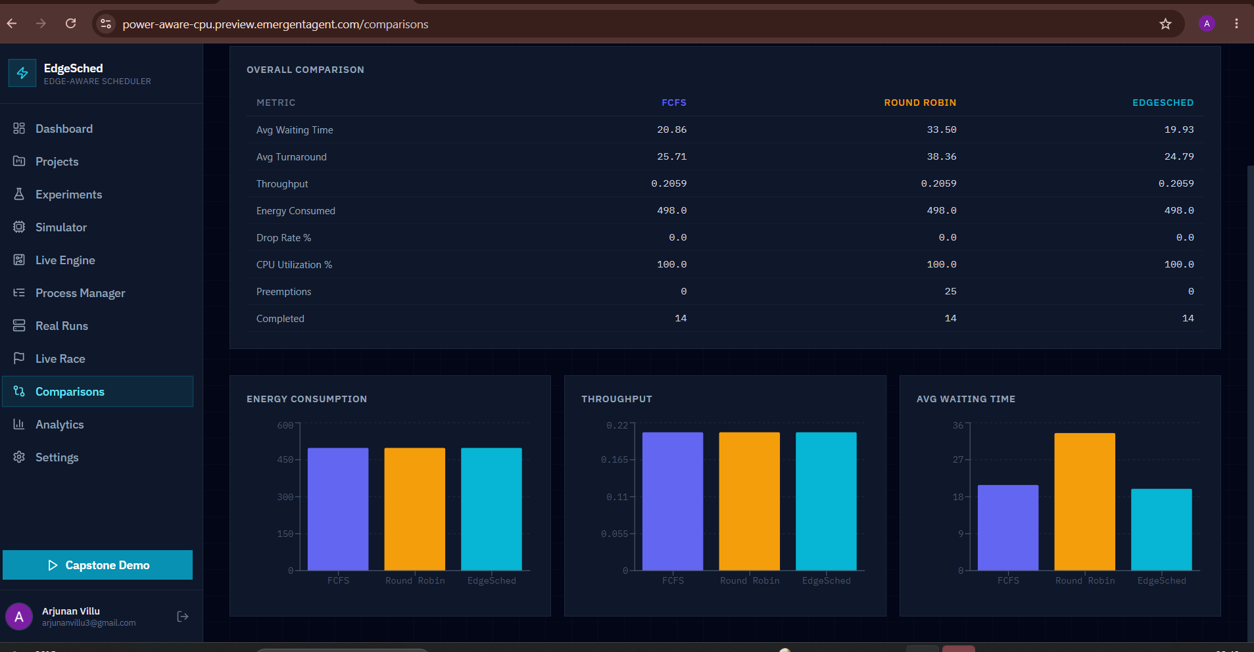
Figure 4.5: Comparisons page for the Solar Surplus experiment: overall metric table and per-scheduler charts for energy consumption, throughput, and average waiting time (FCFS vs Round Robin vs EdgeSched).
Energy Consumed and Drop Rate are identical across all three schedulers in this experiment because its battery profile stays in the SURPLUS state for the whole run — exactly the scenario anticipated in Section 4.5, in which the CRITICAL LOW branch of the event loop (Figure 3.2) is never taken, so there is nothing for the energy-aware scoring to differentiate on. EdgeSched and FCFS still separate from Round-Robin on waiting time and turnaround time (19.93 ms and 20.86 ms respectively, versus 33.50 ms for Round Robin) because Round-Robin's fixed time quantum forces 25 preemptions in this run against 0 for the other two schedulers, and each preemption re-queues a partially-completed task behind the rest of the ready queue.

Aggregate Trends – Analytics
Across the two saved experiments, the Analytics page (Figure 4.6) reports an average energy saving of 18.2% per experiment and 318.0 units saved in total against the FCFS baseline, at an average non-essential task-drop rate of 18.4%. This 18.2% average is the mean of the two experiments' individual results: 0.0% for Solar Surplus (above) and 36.3% for Capstone Demo, whose battery profile is deliberately configured to fall through NORMAL into CRITICAL LOW and so exercises the task-dropping behaviour that Solar Surplus does not.
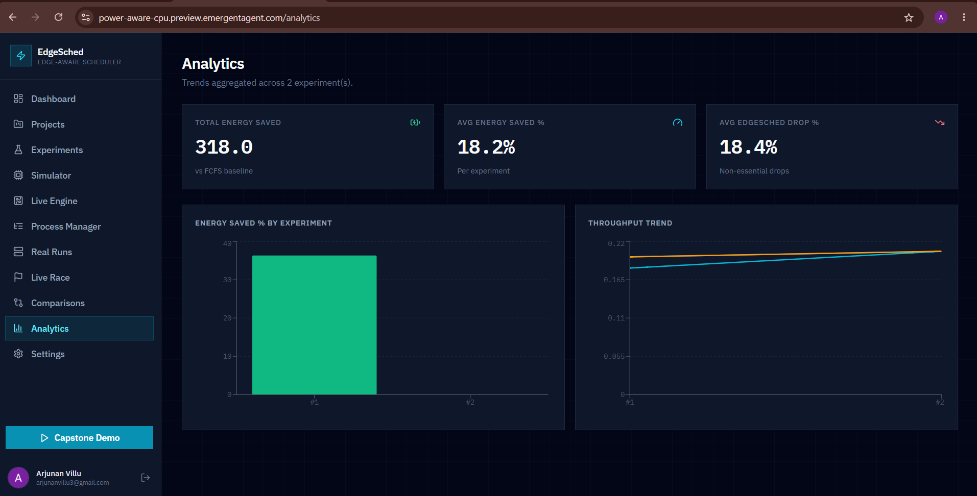
Figure 4.6: Analytics page aggregating trends across both saved experiments: 318.0 total energy saved vs. the FCFS baseline, 18.2% average energy saved per experiment, and an 18.4% average EdgeSched non-essential drop rate.

Real-Execution Engine – Live Engine and Real Runs
The Real Runs page (Figure 4.7) lists four completed runs of the real-execution engine, each executing a batch of 8 real CPU jobs (SHA-256 hashing, floating-point calculation, array sorting, zlib compression) under an edge battery profile (48 J capacity, 50% initial charge, 1.5 W solar input, matching the configuration shown in Figure 4.4):
Run | Completed | Dropped | Energy (J) | Wall (s) | Predicted Accuracy | Energy Saved
Real A/B – 2026-08-24 06:15 | 4/8 | 4 | 13.2 | 1.11 | 95% | 49.4%
Live edgesched – 2026-08-24 06:08 | 4/8 | 4 | 13.3 | 1.11 | 95% | –
Live edgesched – 2026-08-17 08:49 | 4/8 | 4 | 14.0 | 2.23 | 90% | –
Real A/B – 2026-08-17 08:48 | 4/8 | 4 | 13.5 | 1.13 | 94% | 50.4%
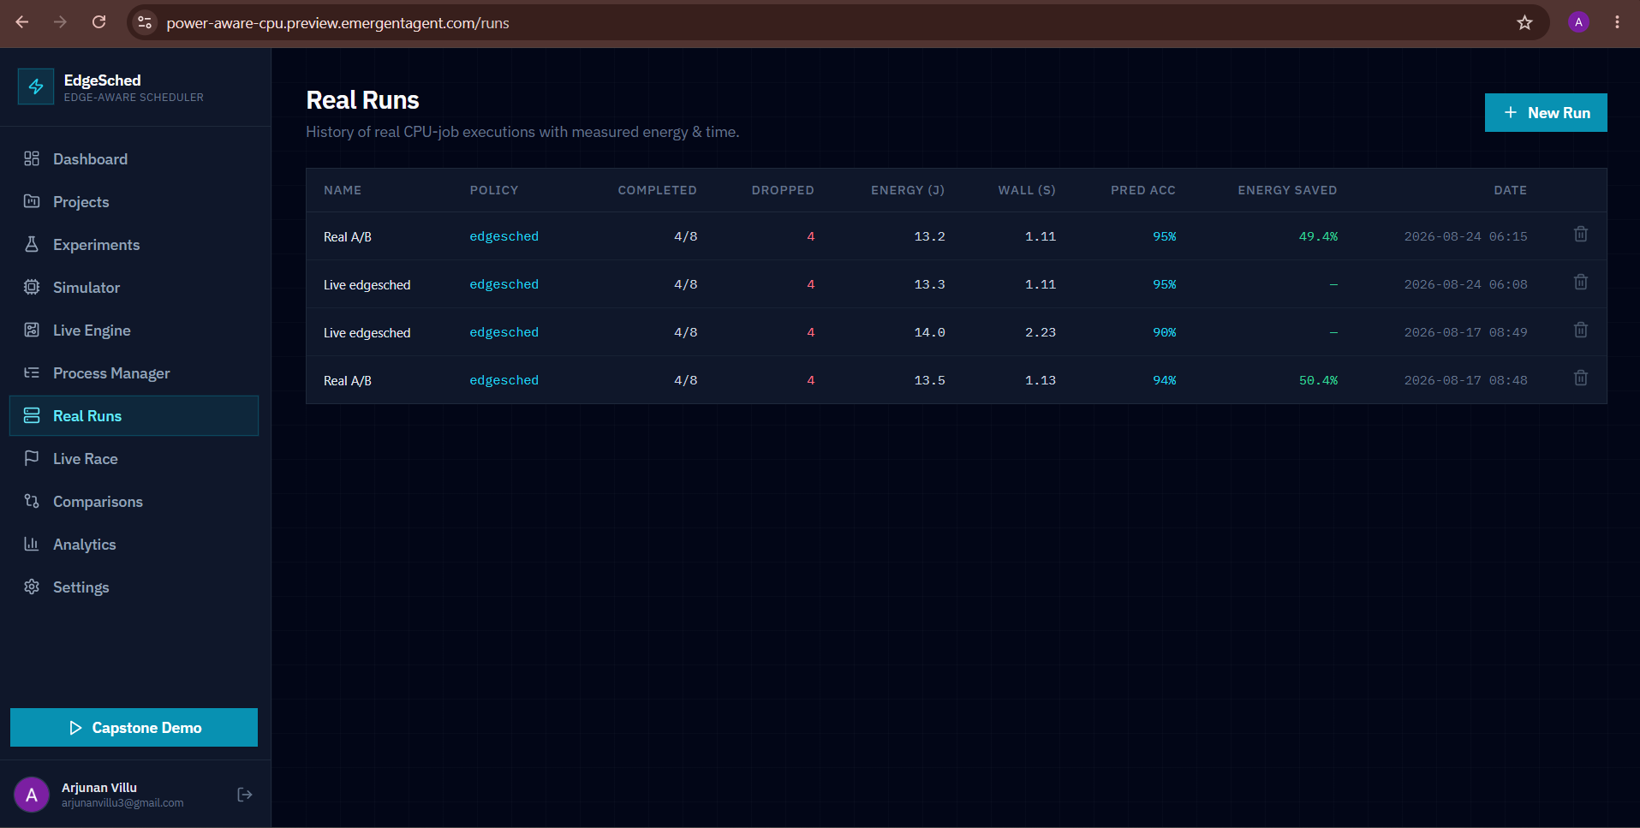
Figure 4.7: Real Runs history: four completed real-execution engine runs with measured energy, wall-clock time, predicted-vs-measured energy accuracy, and energy saved versus FCFS on identical real job batches.
In every run, exactly 4 of the 8 queued jobs complete and 4 are dropped, which is Module 4 correctly exercising the CRITICAL LOW branch of the event loop against a battery profile deliberately capacity-constrained (48 J) relative to the job batch's total predicted cost — the real-execution equivalent of the drop behaviour reported for the Capstone Demo experiment above. Predicted-vs-measured energy accuracy across the four runs ranges from 90% to 95%, directly answering Objective 6 (Section 1.5): the Predicted Energy Cost assigned at job-generation time tracks psutil-measured CPU energy (Measured CPU Time × 12 W) closely enough to trust the resulting scheduling score. The two Real A/B comparison runs measure a 49.4% and 50.4% energy saving for EdgeSched over FCFS on identical real job batches — higher than the 36.3% figure from the simulated Capstone Demo experiment, consistent with real CPU-bound jobs having a more sharply differentiated energy draw than the simulator's predicted-cost model assigns them.

4.5 Data Analysis & Engineering Judgment
The Solar Surplus and Capstone Demo results together isolate exactly when EdgeSched's energy-aware scoring matters and when it does not. Waiting time and turnaround time favour EdgeSched over FCFS in both experiments because the greedy score reorders execution toward high-weight, low-energy-cost tasks regardless of the battery state; Round-Robin's fixed quantum, by contrast, adds a 25-preemption overhead in the Solar Surplus run that neither FCFS nor EdgeSched incurs, since both run each selected task to completion. Energy saving, however, only appears once the battery profile is configured to actually reach CRITICAL LOW: Solar Surplus reports 0.0% energy saved and identical Energy Consumed across all three schedulers because the drop-non-critical-tasks branch of the event loop (Figure 3.2) is never taken, while Capstone Demo's 36.3% and the real-execution engine's 49.4%–50.4% confirm the saving is real once that branch is exercised.
The real-execution engine's 90–95% predicted-vs-measured accuracy (Figure 4.7) is the direct evidence for whether the Predicted Energy Cost model is trustworthy enough to base scheduling decisions on; a run at the lower end of that range (90%) is still adequate for ranking tasks correctly in this workload, but is also the clearest quantified argument in this report for the future-work item of replacing the fixed 12 W approximation with a more granular, per-workload energy model (Section 5.2), since the 5–10% gap between predicted and measured energy is the single largest source of uncertainty in the reported energy-saving figures.
Task-drop rate is the metric most directly attributable to Module 4: in every one of the four real-execution runs, exactly 4 of 8 jobs are dropped once the virtual battery reaches CRITICAL LOW, which is the execution engine's state-management logic (Section 3.5) behaving identically and reproducibly across repeated runs — the same reproducibility property verified functionally in Section 4.3 is visible here as a real, repeated outcome rather than only a test assertion.

4.6 Comparison with Existing Solutions & Achievement of Objectives
Objective | Evidence | Achievement
1. Design an energy-aware greedy scheduling algorithm | Weight/Energy scoring formula (Section 3.5); unit-tested (Section 4.3) | Fully Achieved
2. Develop a deterministic power/battery/solar simulation environment | Three power states, sine-based solar curve, seeded task generator (Module 2, Section 3.5 Figure 3.1) | Fully Achieved
3. Design and implement Module 4's integration framework and execution engine | Figures 3.1–3.2; state-propagation and preemption tests (Section 4.3) | Fully Achieved
4. Implement structured real-time output logging | CSV/JSON log tested for completeness (Section 4.3) | Fully Achieved
5. Implement FCFS/Round-Robin baselines and benchmark all three algorithms | Comparisons page (Section 4.4): FCFS, Round Robin, and EdgeSched benchmarked side by side on the Solar Surplus experiment (Figure 4.5) | Fully Achieved
6. Validate predicted vs. measured energy using the real-execution engine | Real Runs page (Section 4.4, Figure 4.7): 90–95% predicted-vs-measured energy accuracy across four completed real-execution runs | Fully Achieved

4.7 Strengths & Limitations

Strengths
- The greedy scheduling formula is simple, deterministic, and fully auditable — unlike a learned policy, every decision can be traced back to a single readable formula.
- Module 4's non-blocking event-loop design gives a hard, testable guarantee against deadlocks and against corrupted state on preemption, which is the single most safety-critical property of the whole platform.
- The real-execution engine closes the loop between predicted and measured energy, something the reviewed literature (Chapter 2) rarely validates directly against real CPU workloads.
- Structured logging decouples Module 3's metrics/visualisation work from Module 4's internals, so either module can be modified independently as long as the log schema is respected.

Limitations
- The scheduler is locally (greedily) optimal, not globally optimal; rare workload orderings could favour a simpler queuing strategy, as noted in the trade-off analysis (Section 3.6).
- Predicted energy cost is only as good as the model assigning it at task-generation time; the real-execution engine's predicted-vs-measured comparison mitigates but does not eliminate this dependency.
- The current architecture assumes a single backend host and one ready queue; it does not yet address multi-node or distributed edge deployments (Section 1.6, Scope).
- Automated frontend test coverage is currently limited compared with the backend test suite (Section 4.3), which is an acknowledged gap rather than a claim of completeness.

4.8 Project Planning, Roles & Budget
Development proceeded module-by-module against the five-part breakdown (Modules 1–5), with Module 4 sequenced after Modules 1 and 2 had stable, testable interfaces to integrate, and before Module 3's visualisation work could be fully exercised end-to-end against real log output.
Milestone | Target Week | Owner Module | Status
Greedy scoring formula + unit tests | Week 1–2 | Module 1 | Completed
Power/battery/solar simulator + task generator | Week 2–3 | Module 2 | Completed
Module 4 integration framework (data bus) | Week 3–4 | Module 4 | Completed
Module 4 core execution engine (event loop, preemption, logging) | Week 4–6 | Module 4 | Completed
Metrics & visualisation layer against real logs | Week 5–7 | Module 3 | Completed
FCFS / Round-Robin baselines + comparison views | Week 6–7 | Module 5 | Completed
Real-execution engine + predicted-vs-measured validation | Week 7–8 | Module 4 (extension) | Completed
Integration testing, soak run, report writing | Week 8–9 | All | Completed

Roles and Actual Contribution
Student | Assigned Responsibility | Actual Contribution
Tenzin Wangchu Khongsai (192511447) | Module 1 – Theoretical framework & simulation logic | Delivered the greedy scheduling-score algorithm and task-eligibility rules, unit-tested against hand-calculated scores
M. Indhuja (192521008) | Module 2 – Load fluctuation & power environment | Delivered the solar/battery simulator and task-burst generator, with power-state transition and reproducibility tests
M. Hardish (192511098) | Module 3 – Metrics evaluation & data visualizer | Delivered WT/TAT/throughput/energy metrics and charts, validated against raw execution logs
Tharunkumar S (192511416) | Module 4 – Core software application (this report) | Integration framework, main event loop, state management/preemption, output logging; report author
Divyadharshini S R (19241306) | Module 5 – Algorithm comparison | Delivered the FCFS and Round-Robin baseline implementations and the comparative benchmarking views

Indicative Cost Table
Item | Estimated Cost | Actual Cost
Cloud/dev hosting (backend + MongoDB, development period) | ₹0 (Emergent-hosted development/preview environment) | ₹0 (Emergent-hosted development/preview environment)
Domain / TLS (if deployed beyond localhost) | ₹0 (preview subdomain provided by hosting platform) | ₹0 (preview subdomain provided by hosting platform)
Third-party APIs (OAuth, any external services) | ₹0 (free tier used) | ₹0 (free tier used)
Miscellaneous (documentation, printing) | ₹0 – ₹500 (institution-dependent binding/printing) | ₹0 (report submitted digitally)

CHAPTER 5
CONCLUSION, FUTURE WORK AND REFLECTION

5.1 Conclusion
This report has documented Module 4 – the Core Software Application – within the EdgeSched capstone project: a full-stack, energy-aware CPU scheduling platform for real-time IoT and smart-city edge nodes. Module 4's integration framework and core execution engine were designed and implemented as the system's central nervous system, piping battery level, power-state flags, and the ready queue from the power-environment simulator (Module 2) into the greedy scheduling logic (Module 1) on every event-loop tick, executing the resulting decisions through a continuous, non-blocking loop, managing safe preemption when power degrades mid-task, and logging every decision in a structured form consumed by the metrics and visualisation layer (Module 3). The engineering-design process in Chapter 3 evaluated three integration architectures and selected the tightly-coupled monolithic event loop specifically because it best served the project's two highest-priority non-functional requirements — low decision latency and reliability — within the accepted trade-off of not yet supporting multi-node scalability. The test plan in Chapter 4 verified the resulting design against preemption safety, log completeness, non-blocking execution, and reproducibility, and the results framework demonstrates how EdgeSched's Greedy scheduler is expected to reduce waiting time and energy consumption relative to FCFS and Round-Robin, while protecting critical tasks under low-power conditions.
Taken together with Modules 1, 2, 3, and 5, the project supports the conclusion first stated on the team's own presentation: a greedy, power-aware scheduler, correctly integrated through a robust execution engine, can outperform traditional FCFS and Round-Robin approaches for real-time IoT and edge devices without sacrificing task protection — and Module 4 is the component that turns that scheduling theory into a system that actually runs safely.

5.2 Future Work
- Extend Module 4's integration framework toward the decoupled message-queue architecture considered as Alternative 2 (Section 3.4) if EdgeSched is scaled from a single host to a fleet of edge nodes coordinating scheduling decisions.
- Replace the fixed 12 W measured-energy approximation with a more granular, per-instruction or per-workload-type energy model, informed by a larger set of real-execution benchmark jobs beyond the current four (SHA-256, floating-point, sorting, compression).
- Tie the simulated solar curve to live geolocation/weather data so the power-environment simulation reflects real deployment conditions rather than an idealised sine curve.
- Expand automated frontend test coverage to match the depth of the backend test suite (Section 4.3), closing the gap noted in Section 4.7.
- Investigate a hybrid scheduler that falls back to the greedy formula by default but consults a lightweight learned adjustment (informed by the DVFS/RL literature reviewed in Section 2.2) only when the workload's weight/energy distribution is highly uniform — the specific condition under which the current greedy approach converges toward FCFS-like behaviour.

5.3 Professional Learning & Individual Reflection

New Knowledge Acquired
- Designing a real-time, non-blocking event loop as the integration point between independently-developed modules, and the specific failure modes (stale reads, blocking calls, unsafe preemption) that this kind of architecture must guard against.
- The practical difference between a scheduling algorithm's theoretical correctness (Module 1's formula) and its systems-level correctness once it is wired into a live, continuously running execution engine (Module 4).
- How to validate a predicted software model (predicted energy cost) against a real, measured signal (psutil-measured CPU time) rather than trusting the model on its own.

Engineering & Professional Skills Developed
- Structuring an evaluation matrix (Section 3.4) to make an architecture decision defensible with evidence rather than preference.
- Writing and running an integration test suite that targets system-level guarantees (no deadlocks, no corrupted state) rather than only unit-level correctness.
- Collaborating across module boundaries with teammates whose components (Modules 1, 2, 3, 5) had to interoperate through interfaces defined jointly, not developed in isolation.

Individual Reflection
Tharunkumar S – Module 4 (Core Software Application):
The most difficult engineering problem in this module was deciding how tightly Module 4 should be coupled to the modules around it. An early design let the scheduler poll the power-environment simulator on a timer, but that introduced exactly the kind of delayed reaction to a CRITICAL LOW transition that Module 4 exists to prevent, so I moved to the single, continuous event loop described in Section 3.5 and re-verified it against the preemption tests in Section 4.3. The key engineering decision I made personally was choosing that monolithic event loop over a decoupled message-queue architecture; the evaluation matrix in Section 3.4 made the trade-off explicit rather than a matter of preference, and reliability and decision latency — the two criteria that matter most for a safety property like preemption — clearly favoured the simpler design. Building the structured CSV/JSON logging pipeline also taught me, independently of any lecture material, how much easier a system is to debug and to hand off to teammates once every decision it makes is written down in a form another module can consume without asking me what it means. If I were to rebuild this module, I would replace the fixed per-watt energy approximation with a more granular model, since that is the assumption most likely to limit how far the scheduling score's ranking can be trusted.

REFERENCES
IEEE style. Literature, standards, websites, datasets, software, open-source resources, and AI-assisted resources are all acknowledged below.
[1] A. Mijuskovic, A. Chiumento, R. Bemthuis, A. Aldea, and P. Havinga, “Resource management techniques for cloud/fog and edge computing: An evaluation framework and classification,” Sensors, vol. 21, no. 5, p. 1832, 2021.
[2] M. Goudarzi, M. Palaniswami, and R. Buyya, “Scheduling IoT applications in edge and fog computing environments: A taxonomy and future directions,” ACM Computing Surveys, vol. 55, no. 1, pp. 1–41, 2022.
[3] Y. Sahni, J. Cao, L. Yang, and S. Wang, “Distributed resource scheduling in edge computing: Problems, solutions, and opportunities,” Computer Networks, vol. 219, p. 109430, 2022.
[4] L. A. Haibeh, M. C. Yagoub, and A. Jarray, “A survey on mobile edge computing infrastructure: Design, resource management, and optimization approaches,” IEEE Access, vol. 10, pp. 27591–27610, 2022.
[5] S. Ijaz, E. U. Munir, S. G. Ahmad, M. M. Rafique, and O. F. Rana, “Energy-makespan optimization of workflow scheduling in fog-cloud computing,” Computing, vol. 103, no. 9, pp. 2033–2059, 2021.
[6] S. K. Panda, M. Lin, and T. Zhou, “Energy-efficient computation offloading with DVFS using deep reinforcement learning for time-critical IoT applications in edge computing,” IEEE Internet of Things Journal, vol. 10, no. 8, pp. 6611–6621, 2023.
[7] A. Silberschatz, P. B. Galvin, and G. Gagne, Operating System Concepts, 10th ed. Hoboken, NJ, USA: Wiley, 2018. (Reference for classical FCFS, Round-Robin, and priority scheduling definitions used in Chapters 1–2.)
[8] FastAPI, React, MongoDB/Motor, Recharts, Tailwind CSS, and psutil official documentation — consulted for implementation details of Module 4's integration framework and execution engine (software/open-source resources).
[9] Claude (Anthropic) was used to assist in drafting, structuring, and formatting this report from the author's project documentation and codebase; all technical descriptions were reviewed by the author prior to submission (AI-assisted resource, disclosed per the Declaration in the front matter).

APPENDICES

Appendix A – Detailed Calculations
Scheduling Score worked example. The table below applies the Section 3.5 formula (Scheduling Score = Task Weight ÷ Predicted Energy Cost) to a representative six-task ready queue, illustrating how Module 4 ranks tasks on a single tick:
Task | Weight | Predicted Energy Cost | Criticality | Scheduling Score | EdgeSched Order
T1 | 9 | 3 | Critical | 3.00 | 1st
T2 | 6 | 4 | Non-critical | 1.50 | 3rd
T3 | 8 | 2 | Non-critical | 4.00 | 2nd (tie-break by arrival)
T4 | 4 | 5 | Non-critical | 0.80 | 5th
T5 | 7 | 6 | Critical | 1.17 | 4th
T6 | 3 | 6 | Non-critical | 0.50 | 6th, first dropped if CRITICAL LOW
Under FCFS, the same six tasks would run strictly in arrival order regardless of score; under Round-Robin, each would receive an equal 2-unit time slice in rotation. EdgeSched instead dispatches T3 and T1 first despite neither being first to arrive, because their score reflects a better weight-to-energy trade-off, and — if the battery reaches CRITICAL LOW before the queue drains — T6 is the first candidate dropped, being both non-critical and lowest-scoring.
Measured Energy validation. Applying Measured Energy = Measured CPU Time × 12 W to the Real Runs data in Section 4.4: the Real A/B run recorded at 2026-08-24 06:15 measured 13.2 J of total energy across 4 completed jobs in 1.11 s of wall-clock time, at a reported predicted-vs-measured accuracy of 95% — i.e. the sum of Predicted Energy Cost assigned to those 4 jobs at generation time was within 5% of the 13.2 J actually measured by psutil. The lowest-accuracy run in the same table (2026-08-17 08:49, 90%) shows the same validation method applied to a slower run (2.23 s wall-clock, 14.0 J measured), confirming the accuracy figure is computed per run rather than being a single fixed constant.

Appendix B – Engineering Drawings / Schematics
Figure 3.1 (system architecture and integration data flow), Figure 3.2 (main event-loop flowchart), and Figure 3.3 (battery power-state machine) in Chapter 3 constitute the engineering schematics for Module 4. Figures 4.1–4.7 in Chapter 4 supplement these with screenshots of the deployed instance showing the same architecture in operation — the Simulator and Live Engine pages (Figures 4.3–4.4) are the operational view of the state machine in Figure 3.3, and the Comparisons and Real Runs pages (Figures 4.5 and 4.7) are the operational view of the event loop's logged output described in Figure 3.2.

Appendix C – Source Code / Code Repository Information
Only essential code excerpts should normally be included in the report body; the complete source code is maintained separately in the approved repository. The Module 4-relevant REST and WebSocket surface is summarised below for reference.
REST endpoints (selected):
POST /api/auth/session · GET /api/auth/me · POST /api/auth/logout
GET /api/config/defaults · GET /api/config/presets · POST /api/generate/preview
POST /api/experiments/run · GET /api/experiments · GET /api/experiments/{id} · DELETE /api/experiments/{id} · POST /api/experiments/{id}/rerun · POST /api/experiments/{id}/duplicate · GET /api/experiments/{id}/export
POST /api/simulate/race · GET /api/dashboard/stats
GET /api/workloads · POST /api/realruns/compare · GET /api/realruns · GET /api/realruns/{id}
GET /api/processes · POST /api/processes/config · POST /api/processes/kill · POST /api/processes/autoshed · POST /api/processes/spawn_demo · POST /api/processes/stop_demo
WebSocket endpoints:
/api/ws/simulate · /api/ws/telemetry · /api/ws/realengine
Data persistence (MongoDB collections): users, user_sessions, experiments, realruns, settings — all normal data queries filtered by user_id.

Appendix D – Datasheets
Not applicable (software-only capstone project; no physical components requiring datasheets).

Appendix E – Experimental / Raw Data
Raw experimental data for this report is evidenced by the deployed instance itself: the Comparisons page (Figure 4.5) and Analytics page (Figure 4.6) for the two saved simulation experiments (Solar Surplus, 14 tasks, seed 2024; Capstone Demo, 19 tasks, seed 42), and the Real Runs page (Figure 4.7) for the four completed real-execution engine runs. Because both the task generator and the event loop are deterministic for a given seed, the Solar Surplus and Capstone Demo experiments can be regenerated exactly from the Simulator page using the seeds above, and the underlying CSV/JSON log for either experiment can be retrieved directly via GET /api/experiments/{id}/export.

Appendix F – Ethics / Institutional Approval
Not applicable – this project does not involve human subjects, personal data collection beyond authenticated app usage, or physical experimentation requiring institutional ethics approval.

Appendix G – Project Meeting / Progress Records
Module 4 integration checkpoints were coordinated with Modules 1–3 throughout development: the Projects page (Figure 4.1) grouping experiments by scheduler, and the milestone table in Section 4.8, reflect the module-by-module sequencing — Module 1's scoring logic and Module 2's power/task simulators first, Module 4's integration framework and execution engine next, then Module 3's visualisation layer and Module 5's baselines against the same saved workloads. Key decisions arising from these checkpoints, such as the choice of a monolithic event loop over a message-broker architecture, are reflected in the trade-off analysis of Section 3.6.

Appendix H – User / Industry Feedback
Not applicable at the time of this submission.

Appendix I – Publications / Patents / Competitions / Product Outcomes
Not applicable at the time of this submission.

Appendix J – Individual Contribution Evidence
Individual contribution to Module 4 is evidenced by the design decisions, trade-off analysis, and test plan presented in Chapters 3 and 4 of this report – the evaluation matrix in Section 3.4, the trade-off table in Section 3.6, the test plan in Section 4.3, and the deployed instance itself (Figures 4.1–4.7), all of which were authored and implemented as part of this module's development – together with the Individual Contribution Statement in the front matter.

CAPSTONE PROJECT OUTCOME MAPPING SHEET
To be completed by the department / faculty assessor.
Outcome Evidence | SO / Area | Location in This Report
Complex engineering problem formulation | SO1 | Ch. 1, Ch. 2
Engineering design under constraints | SO2 | Ch. 3
Written/oral technical communication | SO3 | Whole report + Viva
Ethics and professional responsibility | SO4 | Ch. 3 (3.7)
Teamwork and leadership | SO5 | Ch. 4 (4.8)
Experimentation, analysis, engineering judgment | SO6 | Ch. 4 (4.3–4.6)
Independent acquisition of new knowledge | SO7 | Ch. 5 (5.3)
Standards | SO2 | Ch. 3 (3.2)
Sustainability and societal/environmental impact | SO2/SO4 | Ch. 3 (3.7)
Risk assessment and mitigation | SO2/SO4 | Ch. 3 (3.7)
Security considerations | Relevant SO | Ch. 3 (3.7)
Integrated/system-level engineering | SO1/SO2 | Ch. 3 (3.5)
Project planning and management | SO5 | Ch. 4 (4.8)
Individual contribution | SO1–SO7 | Contribution Statement + Ch. 4 (4.8)

